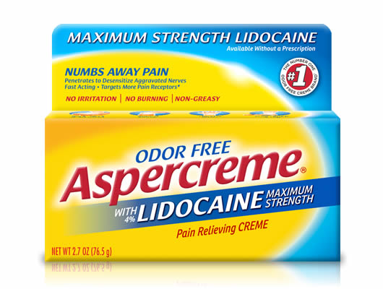

Pain Relieving Creme
with Lidocaine
Desensitizes Aggravated Nerves with Maximum Strength Lidocaine
- Maximum Amount of LIdocaine Available without a Prescription*
- Targets More Pain Receptors than any other OTC Topical Analgesics**
- Odor Free
- Numbs Away Pain with No Irritation and No Burning
Available Sizes:
- 1.75 oz
- 2.7 oz
- 4.7 oz

Active Ingredient
Lidocaine HCI 4% . . . . . . . . . . . . Topical anesthetic

Inactive Ingredients
acrylates/C10-30 alkyl acrylate crosspolymer, aloe barbadensis leaf juice, aminomethyl propanol, C30-45 alkyl cetearyl dimethicone crosspolymer, caprylyl methicone, cetearyl alcohol, ceteth-20 phosphate, dicetyl phosphate, dimethicone, disodium EDTA, ethylhexylglycerin, glyceryl stearate, methylparaben, SD alcohol 40 (15%), steareth-21, water (309-124)

Warnings
For external use only
Do not use
- on large areas of the body or on cut, irritated or swollen skin
- on puncture wounds
- for more than one week without consulting a doctor
When using this product
- use only as directed. Read and follow all directions and warnings on this carton.
- do not allow contact with the eyes
- do not bandage or apply local heat (such as heating pads) to the area of use
Stop use and ask a doctor if
- condition worsens
- symptoms persist for more than 7 days or clear up and occur again within a few days
If pregnant or breast-feeding, ask a health professional before use.
Keep out of reach of children and pets. If swallowed, get medical help or contact a Poison Control Center right away.

Directions
adults and children over 12 years:
- apply a thin layer to affected area every 6 to 8 hours, not to exceed 3 applications in a 24 hour period
children 12 years or younger:
- ask a doctor

Uses
temporarily relieves minor pain

