USA SUPPLY
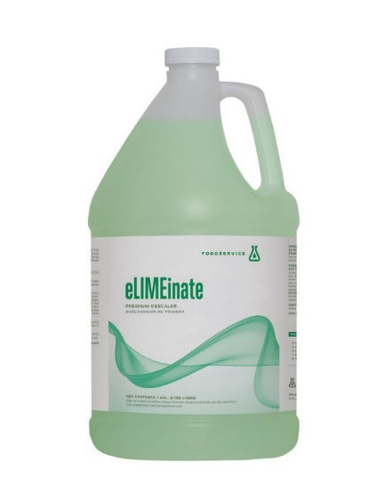
f O O D s e R V i C e

Eliminate
sizes: 1 gal.
Premium descaler

Eliminate calcium and other hard water mineral deposits with Eliminate - a mineral acid that attacks grime and scale build-up in dish machines . This non-foaming cleaner works effectively to descale deposits from wash arms, spray jets and interior dish machine walls . Also effective on foodservice equipment and rust removal . A machine cleaned with Eliminate operates more efficiently, because water flow is unhampered by hard water build-up . Eliminate maximizes rinse action, so dishes are completely clean, every time! Regular descaling with Eliminate also prevents dish machine breakdowns and service calls, a savings that can really impact the bottom line!

PRODUC T SPECIFICATIONS
Product code and Pack Size:
300892CGH1-4 . . . . . . . . . . . . . . . . . . . . . . . . . . . . . . . . . . . . . . . . . . . . . . . . 4 x 1 gallon

kosher information: CRC Certified

TECHNICAL INFORMATION
Appearance / Color . . . . . . . . . . . . . . . . . . . . . . . . . . . . . . . . . . . . . . . .Clear Green
Odor . . . . . . . . . . . . . . . . . . . . . . . . . . . . . . . . . . . . . . . . . . . . . . . . . . . . . .. . . . . . . . . . . . .Acid
Shelf Life . . . . . . . . . . . . . . . . . . . . . . . . . . . . . . . . . . . . . . . . . . . . . . . . . . . . . . . . 2 years
Foaming . . . . . . . . . . . . . . . . . . . . . . . . . . . . . . . . . . . . . . . . . . . . . . . . . . . . . . . . . . . None
Solubility in Water . . . . . . . . . . . . . . . . . . . . . . . . . . . . . . . . . . . . . . . Complete
Specific Gravity . . . . . . . . . . . . . . . . . . . . . . . . . . . . . . . . . . . . . . . . . 1 .1645 ± 0 .005 pH . . . . . . . . . . . . . . . . . . . . . . . . . . . . . . . . . . . . . . . . . . . . . . . . . . . . . . . .. . . . . .<1 .0 +/-0 .5 Storage Temperature . . . . . . . . . . . . . . . . . . . . . . . . . . . . . . . . . . . . . . . . . 45 - 110 °F

FEATURES AND BENEFITS
Removes Scale Build-Up Maximizes Rinse Action Minimizes Rejects
Keeps Dish Machines Running At Top Efficiency Contains Corrosion Inhibitors

IMPORTANT SAFETY INFORMATION
Precautions: Do not get in eyes, on skin or clothing . Use with adequate ventilation . Wash thoroughly after handling . eye contact: Immediately flush eye with plenty of cool, running water . Remove contact lenses if applicable, and continue flushing for at least 15 minutes, holding eyelids apart to ensure thorough rinsing of the entire eye . GET IMMEDIATE MEDICAL ATTENTION . Skin contact: Wash off immediately with soap and plenty of water while removing all contaminated clothes and shoes . ingestion: Do NOT induce vomiting . Give large amounts of water if victim is conscious . Never give anything by mouth to an unconscious person . Get medical attention immediately . inhalation: If victim shows signs of discomfort or irritation, remove to fresh air . If symptoms persist, get immediate medical attention .

Keep container closed when not in use. Keep out of reach of children

DETAILED USAGE AND INSTRUCTIONS
Machine dishwasher descaler : (1) Turn detergent feed system to the “OFF” position . (2) Fill dishwasher with clean water. (3) Add Eliminate to water. Dilute 1:20 up to 1:64 in all tanks . Caution: pour at arm’s length with eyes and face turned away from tank. avoid skin and eye contact by using rubber gloves, aprons and safety goggles. (4) Cycle solution and water mixture for a minimum of 20 minutes . Note: on the hobart am 14 move the toggle switch (a) to manual position! Move toggle switch (B) to the wash position.this will allow machine to run constantly while in deliming procedure. Switch toggle back to auto when finished. (5) Rinse properly by draining and refill with clean water. Cycle for a minimum of 2 minutes. Use rinse toggle switch (B) to flush the machine of the deliming solution. (6) Drain . (7) Check rinse and wash arms to be sure they move freely if not, contact your supervisor. (8) Refill with fresh water and place the detergent feed
System back to the “ON” position . (9) Your machine is now ready for use. Wipe outside of machine with solution in tank and wipe dry .
For large conveyor dish machines, you can (1) reverse detergent capsule as to stop any detergent feeding in (2) drain and refill dishmachine with fresh water (3) Pour in (with full length of arm) the gallon of Eliminate into the wash tank (4) Turn on dishmachine and allow it to run (5) Leave the product in the machine over night (6) Next morning, run the machine again for 10 minutes and then drain it all out (7) Re fill with water and reverse the detergent capsule as to add detergent when needed.
Stainless food service equipment, porcelain, ceramic surfaces: Dilute 2 to 4 ounces per gallon in hot water . Mop, brush, or spray on and rinse off. Wipe dry to shine if desired. Rust removal: Dilute 4 to 6 ounces per gallon in warm water . Dip or mop on surface . Scrub with wire brush or other abrasive device. Rinse and wipe or blow dry . Treat with oil to prep
USA LEASE INC D/B/A USA SUPPLY 803-269-1588

